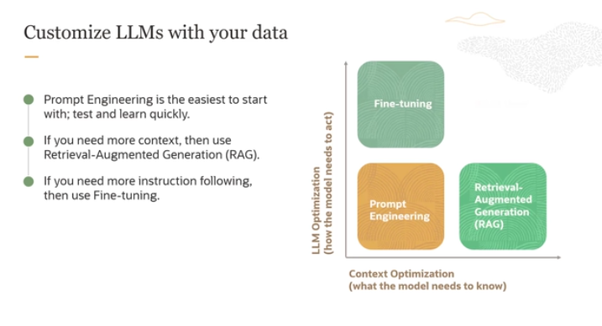

The image and explanation you've provided outline a framework for customizing Large Language Models (LLMs) with your own data, focusing on different techniques based on the model's needs and the specific requirements of the tasks. Here's a simplified explanation:

**Two Main Axes of Customization**

1. **Horizontal Axis - Context Optimization**:
   * **Purpose**: This involves providing the LLM with specific, detailed information it needs to perform tasks more effectively.
   * **Example**: If you're using an LLM for an e-commerce website, you might feed it user-specific information like previous orders to make product recommendations more relevant.
   * Basically in this axis we have to provide context mmm
2. **Vertical Axis - LLM Optimization**:
   * **Purpose**: This focuses on adapting the LLM to perform specific tasks or operate within a particular domain effectively.
   * **Example**: Fine-tuning the model to specialize in legal terminology and case analysis if it's being used in a legal domain.

**Methods of Customization**

1. **Prompt Engineering**:
   * **Description**: The simplest and quickest method to start with. It involves crafting the input (prompt) given to the LLM in a way that guides it to produce the desired output.
   * **Advantages**: Easy to implement and allows for rapid testing and iteration.
2. **Retrieval-Augmented Generation (RAG)**:
   * **Description**: This method integrates retrieval of external data into the generation process. It's useful when the model needs more context beyond what is provided in the initial prompt.
   * **Use Case**: Enhancing responses with additional, relevant information pulled from a database or other sources.
3. **Fine-Tuning**:
   * **Description**: A more in-depth customization where the LLM is trained further on a specific dataset to improve its performance on particular tasks.
   * **Use Case**: Necessary when the model needs to follow detailed instructions or when accuracy in a specialized domain is critical.

**Integration of Methods**

* These methods are additive, meaning you can combine them to enhance the model’s capabilities. For instance, you might start with prompt engineering to see initial improvements and then incorporate RAG or fine-tuning as needed to meet more complex requirements.

**Conclusion**

The framework provides a structured approach to effectively adapt LLMs to your specific needs, improving their relevance and effectiveness in specialized applications or with particular types of data. Each technique builds on the others, offering a comprehensive strategy for optimizing LLM performance across various contexts and requirements.

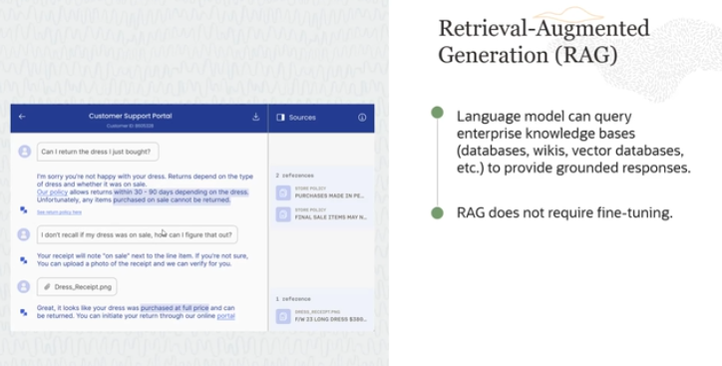

**What is Retrieval Augmented Generation (RAG)?**

* **Purpose**: RAG is a technique where a language model accesses external data sources (like databases or wikis) to provide accurate and relevant responses.
* **Grounded Responses**: The term "grounded" means that the responses from the model are based on verifiable information from these external sources.

**Example Explained:**

Imagine a scenario where a customer is interacting with a chatbot about returning a recently purchased dress.

1. **Initial Query**:
   * **Customer**: Wants to return the dress.
   * **Chatbot**: Confirms the return is possible but needs to check the return policy.
2. **Retrieval**:
   * **Action**: The chatbot accesses an enterprise database to look up the return policy.
   * **Information Retrieved**: The policy states returns are allowed within 30 to 90 days and items should not be on sale.
3. **Interaction Continues**:
   * **Chatbot**: Informs the customer about the return policy.
   * **Customer**: Unsure if the item was on sale.
4. **Further Retrieval**:
   * **Action**: The customer uploads a receipt, and the chatbot uses a vision service to extract the purchase date and price.
   * **Further Check**: The chatbot again consults the database to confirm the item’s eligibility for return based on the sale status and purchase date.
5. **Conclusion**:
   * **Final Response**: The chatbot confirms that the item can be returned.

**Advantages of RAG:**

* **No Need for Fine-Tuning**: Unlike other methods that require the model to be retrained with specific data, RAG simply pulls information from existing databases.
* **Dynamic and Relevant**: By accessing up-to-date databases, the chatbot always provides responses that are current and accurate.
* **Access to Private Knowledge**: RAG allows models to utilize specific, possibly private, databases that they wouldn’t have access to otherwise, enhancing the relevance and precision of the responses.

**How it Works:**

* **Retrieval**: The model searches through a database or corpus of information relevant to the user’s query.
* **Augmented Generation**: Using the information retrieved, the model crafts a response that is informed and accurate.

**Conclusion:**

RAG implementation allows for more intelligent, informed, and accurate interactions between language models and users by leveraging external data sources. This example of a chatbot handling a return inquiry illustrates how RAG can significantly improve the functionality and utility of chatbots in real-world applications.

In simple terms, jo ChatGpt ya koi be model that oh uskay liya ek yeh challenge tha kay wo jis dataset pa train hua hai usi may say response generate krkay de skta hai But out of that wo current koi be information nhi bta skta . But now the RAG made it possible , bcuz RAG nay ChatGpt ko yeh facility provide krdi kay ab jo koi info uskay dataset may nhi hai wo kisi be external source like Database, vector Db, Wikipedia, websites etc say **retrieve** krkay or then **Augmented Generation** uss info ko ek formal and understandable form may convert krka LLM ko dedaga.

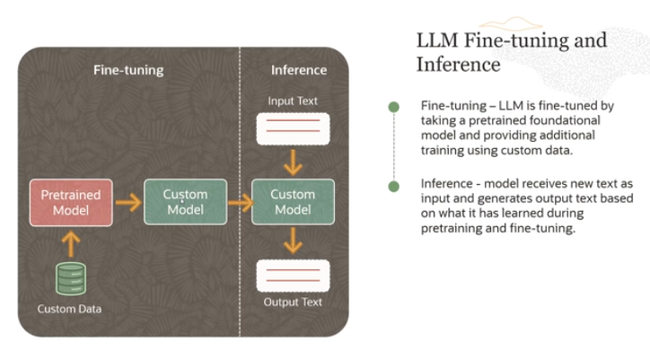

Certainly! The process described involves two key stages used when working with Large Language Models (LLMs) like ChatGPT or other advanced AI models: **fine-tuning** and **inference**. Let’s break down these concepts into simpler terms:

**Fine-Tuning**

* **Pre-trained Foundational Model**: This is a model that has already been trained on a large dataset. It has learned a lot of general information about language from this initial training.
* **Custom Data**: This is specific data relevant to the tasks or the domain you want the model to perform well in. For example, if you are developing a legal advice chatbot, you might use legal documents and case summaries as your custom data.
* **Process**: Fine-tuning involves training this pre-trained model further on your custom data. This helps the model learn specific knowledge and nuances from your data, making it more tailored to your needs.

**Inference**

* **New Input Text**: After the model is fine-tuned, it is ready to be used. This phase is called inference, where you give the model new text it hasn't seen before.
* **Output Generation**: The model uses the knowledge it acquired during its initial pre-training and the subsequent fine-tuning to generate responses. It draws on its enhanced understanding to produce relevant and accurate outputs.

**Summary**

**Fine-tuning** helps adapt a general-purpose model to specific tasks by training it further on specialized data. **Inference** is when the enhanced model applies what it has learned to new text inputs to generate useful responses. This combination allows LLMs to perform effectively in specific applications, improving their utility and accuracy in real-world tasks.

**Q- When we should use RAG and When to use Fine tune with example ?**

**1. When to Use Retrieval-Augmented Generation (RAG)**

**When to Use RAG:**

* **Dynamic Information**: Use RAG when the model needs access to constantly changing or external information (e.g., databases, wikis, documents) that it doesn't inherently know. This is particularly useful when the data is too large, private, or updated frequently, and it's not practical to fine-tune the model with all that information.
* **Limited Need for Customization**: RAG works well when the base model already performs well for the task, but it occasionally needs to look up information or provide more detailed answers.
* **No Need for Fine-tuning**: If the model should be able to search for the latest information (like FAQs, company policies, or product catalogs) without training it on specific data, RAG is suitable.

**Example:**

Imagine you're building a **customer support chatbot** for an e-commerce site. The return policy, available products, and customer data might frequently change. Instead of fine-tuning the model with every update to the policy, you could use RAG. The chatbot can dynamically retrieve the latest policy details from the company’s knowledge base whenever a user asks about returns.

This way, the model is always up-to-date without retraining every time there’s a new policy.

**Key Benefit**: RAG allows the model to **stay current** without needing frequent retraining and is perfect for tasks where the external data may change regularly.

**2. When to Use Fine-tuning**

**When to Use Fine-tuning:**

* **Domain-Specific Knowledge**: Use fine-tuning when you want the model to become very proficient in a specific domain (like medicine, legal advice, or customer service) where the foundational model doesn't have enough specialized knowledge.
* **Custom Instructions or Tasks**: If you need the model to follow specific instructions that it doesn’t already know how to execute effectively, fine-tuning is a good option.
* **Consistent Task Performance**: When the tasks and data are stable, and you don’t need to frequently update the model, fine-tuning helps tailor the LLM to give more accurate, relevant answers.

**Example:**

Imagine you're developing a **legal document analysis tool** for lawyers. The LLM can be fine-tuned using legal texts, case summaries, and statutes to better understand legal language and terms. Once fine-tuned, the model becomes highly skilled at understanding and analyzing legal documents and giving detailed legal advice.

Fine-tuning in this case would involve training the LLM on thousands of legal documents so that it could consistently deliver precise and contextually relevant responses in the legal domain.

**Key Benefit**: Fine-tuning makes the model **specialized** and proficient in handling tasks that require deep expertise in a particular domain.

So mainly , Jab asa data ho which is too large and on the other hand that data is Changing frequently like stock prices So In that situation we can use RAG, bcuz Rag provide the facility to LLM for accessing the current info and providing it as response. But agr hum chahtay hain humara model ek specific Domain pa fully train hojaye and that Data is also not changing frequently So in that case we use **Fine-tuning.**

**How fine-tuning works ?**

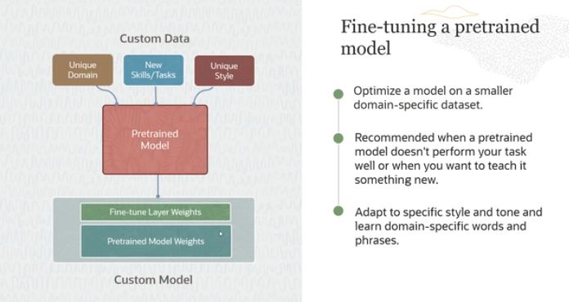

**Fine-Tuning a Pretrained Model**

**Custom Data Inputs**

* **Unique Domain**: The data specific to a particular field or industry.
* **New Skills/Tasks**: Tasks that the original model was not trained on.
* **Unique Style**: A specific writing style or tone that needs to be reflected in the model's outputs.

**Process of Fine-Tuning**

1. **Start with a Pretrained Model**: You begin with a model that has been pretrained on a large, general dataset. This model has learned a broad understanding of language but might not be specialized in any particular domain.
2. **Infuse Domain-Specific Data**: You then train (fine-tune) this model on a smaller, domain-specific dataset. This dataset is tailored to include examples of the unique tasks, style, or domain-specific content you want the model to learn.
3. **Fine-Tune Model Weights**: During fine-tuning, the weights (parameters) of the pretrained model are adjusted to better align with the new data. This step helps the model become more adept at your specific requirements.
4. **Resulting Custom Model**: The outcome is a custom model that is now better equipped to handle the specific tasks, style, or domain that was lacking in the original training.

**Application Example**

* **Scenario**: Suppose you have a legal document review AI that uses a basic LLM. This model is good with general text but not specialized in legal terminology or the structure of legal documents.
* **Fine-Tuning**: You would fine-tune this model on a dataset composed of legal documents, case law summaries, and legal opinions to teach it the specific language, style, and format used in legal writing.

**Advanced Fine-Tuning Techniques**

* **Selective Weight Updating**: Instead of updating all the weights in the model, advanced methods like T-Few might update only a fraction of them or add new layers specifically designed for the new tasks. This approach can reduce training time and computational costs while still enhancing the model’s capabilities.
* **Efficiency and Cost-Effectiveness**: By selectively updating weights or adding new layers, you optimize training efficiency. This means you get a model tailored to your needs without the extensive resources typically required for retraining an entire model.

**Conclusion**

Fine-tuning allows you to leverage the vast knowledge base of a pre-trained LLM while molding it to perform well in niche tasks, domains, or styles. This process transforms a generalist model into a specialist tool, making it vastly more effective for your specific needs.

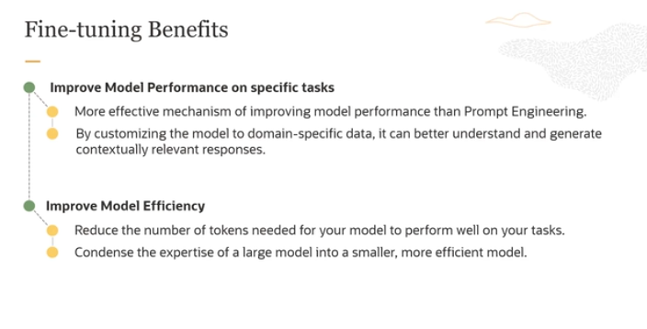

There are two main benefits of fine-tuning. The first is you are improving the model performance on specific tasks. It can better because you are customizing the model to domain-specific data, it can better understand and generate contextually relevant responses. So that's number one.

Number two is you are also improving the model efficiency. You are reducing  the number of tokens. And you're condensing the expertise of a large model into a smaller, more efficient model. So those are two advantages, both improvi-ng model performance and also model efficiency.

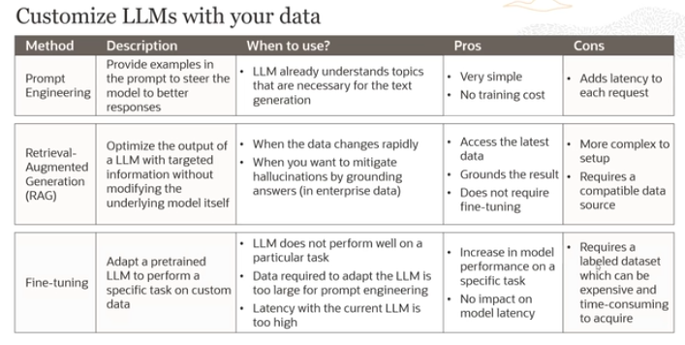

**1. Prompt Engineering**

* **Description**: This method involves providing examples within the prompt to steer the model towards generating more accurate and relevant responses.
* **When to Use**: It's suitable when the LLM already has a good understanding of the topics needed for the task, and you just need to guide it slightly to improve response quality.
* **Pros**:
  + Very simple to implement.
  + No additional training costs involved.
* **Cons**:
  + Can increase the time it takes for each request to process because of the additional data processing required in the prompt.

**2. Retrieval-Augmented Generation (RAG)**

* **Description**: This approach optimizes the model's output by using targeted information retrieval to supplement the generation process without altering the underlying model.
* **When to Use**: Ideal when up-to-date or specific information is needed to answer queries, especially when data changes rapidly or to avoid hallucinations (incorrect information generation) in enterprise settings.
* **Pros**:
  + Provides access to the latest data.
  + Helps ground the model's responses in factual information.
  + Does not require model retraining.
* **Cons**:
  + More complex setup required.
  + Requires a data source that is compatible with the model.

**3. Fine-tuning**

* **Description**: This involves adapting a pretrained model to perform well on tasks tailored to specific needs by training it further on a customized dataset.
* **When to Use**: Best used when the LLM does not perform adequately on a specific task or when the dataset needed to improve the model is too large for simple prompt engineering. It’s also useful when latency with the current model is too high.
* **Pros**:
  + Significantly improves model performance on specific tasks.
  + Customizes the model to understand and generate responses relevant to particular domains.
  + Does not impact latency once implemented.
* **Cons**:
  + Requires a labeled dataset, which can be costly and time-consuming to develop.
  + Involves a complex and potentially lengthy training process.

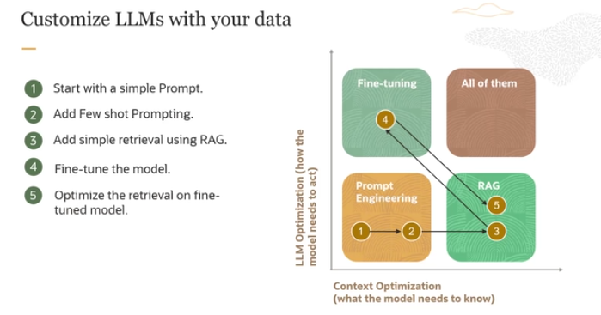  
The image you've provided outlines a strategic framework for customizing Large Language Models (LLMs) with your data, illustrating a step-by-step process on how to incrementally enhance the model’s performance through various techniques. Here’s a detailed breakdown of the steps shown in the image and their context:

**1. Start with a Simple Prompt**

* **What it Involves**: Begin by crafting a basic prompt to establish a baseline for how the model currently performs with your data. This step is crucial to understand the model's initial capabilities without any customization.
* **Purpose**: To gauge the effectiveness of the LLM in handling your specific data or tasks in its raw, unmodified state.

**2. Add Few-shot Prompting**

* **What it Involves**: Introduce a few examples of the specific input/output pairs you want the LLM to learn. This is known as few-shot learning, where the model is given a small number of examples to adapt its responses.
* **Purpose**: To slightly tailor the model's responses based on specific examples without extensive training, enhancing its ability to handle similar tasks.

**3. Add Simple Retrieval Using RAG**

* **What it Involves**: Implement Retrieval-Augmented Generation (RAG) by connecting the model to an enterprise knowledge base. This allows the model to pull in external information to support its responses.
* **Purpose**: To enhance the model’s capability to provide accurate and contextually rich responses by augmenting its knowledge base from external sources.

**4. Fine-tune the Model**

* **What it Involves**: After assessing the effectiveness of RAG, you might proceed to fine-tune the model on a larger and more specific dataset related to your tasks or domain.
* **Purpose**: To deeply integrate domain-specific nuances and improve the model’s overall performance on tasks that are critical to your objectives.

**5. Optimize the Retrieval on Fine-tuned Model**

* **What it Involves**: Once the model is fine-tuned, further optimize the retrieval process to enhance how the model pulls and utilizes external data.
* **Purpose**: To ensure that the retrieval component works efficiently with the newly fine-tuned model, providing an even more refined and accurate output.

**Application of the Framework**

* **Iterative Process**: The process is iterative and cyclical. You may find that after implementing one strategy, you need to revisit and adjust previous steps to better align with your evolving requirements.
* **Adaptability**: Depending on the results at each stage, you can choose to further enhance the model using one or more of these techniques until the desired performance is achieved.

**Conclusion**

This framework is a comprehensive approach to incrementally enhancing an LLM's performance, tailored to specific needs by employing a combination of prompt engineering, few-shot learning, RAG, and fine-tuning. Each step builds upon the previous one, allowing for a customized model that is progressively optimized for higher accuracy and better performance on specialized tasks.

Also remember jo LLMs hai unka jo main objective hai wo realtime information provide krna nhi hai bcuz uskay liya humaray pass Search engines hain like Google,bing etc But jo LLM ka main kam ha wo hai human ki productivity ko increase krna usko new content generate krkay dena LIKIN kiu kay ab hum LLM say yeh be expect krtay hain kay wo humay realtime info dey toh iss lia humaray pass ek system hai which is called RAG for acquiring realtime info BUT that is still not fast in acquiring realtime info as compare to search engines. Bcuz jo search engine hain wo jo incident 10 mins before be hua hai wo be btadenga but for LLM it’s a challenge.

Which aspect's absence in your application renders fine-tuning unnecessary for Large Language Models (LLMs)?

Ans: tohi ska answer hai “ task-specification adaption” mtlb kay jab wo kisi specific task ko sai say perform krnay lg jayega toh we don’t need to fine-tune that model.

What aspect of Large Language Models significantly impacts their capabilities, performance, and resource requirements?

Ans: Model size and parameters, including the number of tokens and weights